**SQL LAB - 1**

SELECT * FROM user_data

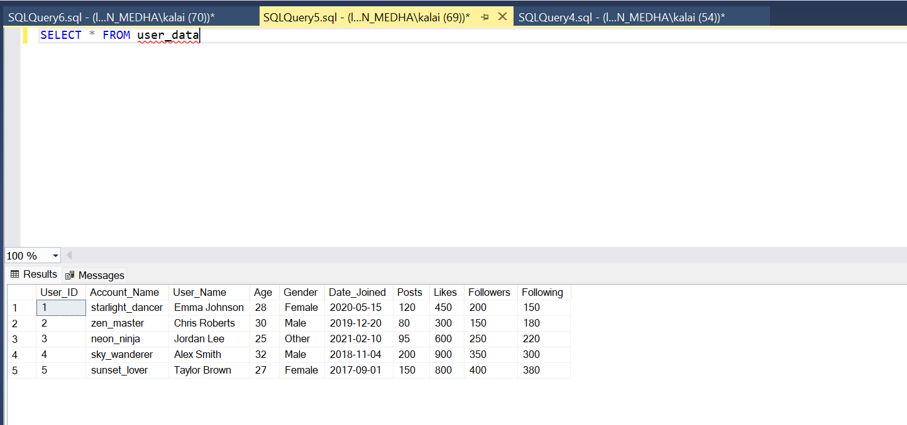

**SQL Tasks**

**Task 1.** Write a query to fetch all users' account names and their number of followers, sorted in descending order by the number of followers.

SELECT Account_Name, Followers FROM user_data ORDER BY Followers DESC

**Task 2.** Write a query to retrieve the account names of all female users who joined before 2020.

SELECT Account_Name FROM user_data where Gender = 'Female' AND Date_Joined < '2020-01-01'

**Task 3.** Write a query to find all users who have more than 100 posts and less than 500 likes.

SELECT Account_Name, Posts, Likes FROM user_data where Posts > 100 AND Likes < 500

**Task 4.** Write a query to count the number of users who joined after January 1st, 2020.

SELECT COUNT(*) AS User_Count FROM user_data WHERE Date_Joined > '2020-01-01'

**Task 5.** Write a query to group users by gender and show the total number of likes per gender.

Select Gender, Sum(Likes) AS Total_Likes FROM user_data GROUP BY Gender

**Task 6.** Write a query to find the total number of posts made by all users combined.

Select Sum(Posts) AS Total_Posts FROM user_data

**Task 7.** Write a query to find the average number of likes for users with more than 200 followers.

Select AVG(Likes) AS Avg_Likes FROM user_data WHERE Followers > 200 GROUP BY Followers

**Task 8.** Write a query to retrieve the account names and likes of the top 3 users with the most likes.

Select TOP 3 Account_Name, Likes FROM user_data ORDER BY Likes DESC

